**Multi-Value URL Lookup**

**Data Adapters:**

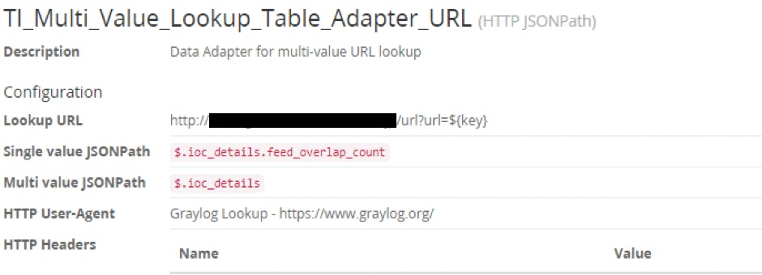

**Cache:**

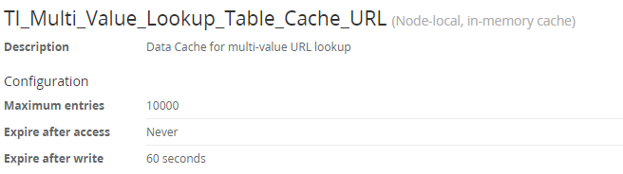

**Lookup Table:**

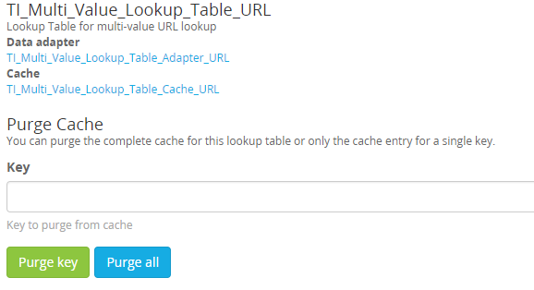

**Multi-Value IP Address Lookup**

**Data Adapters:**

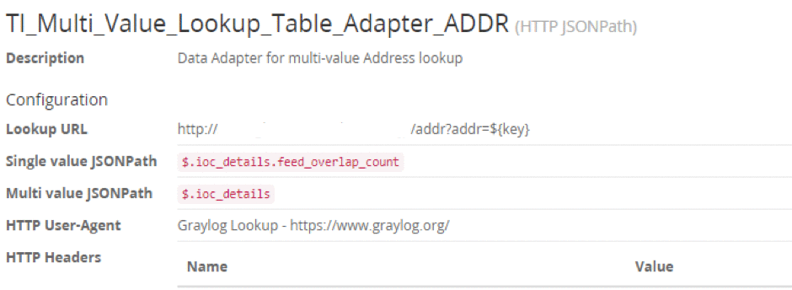

**Cache:**

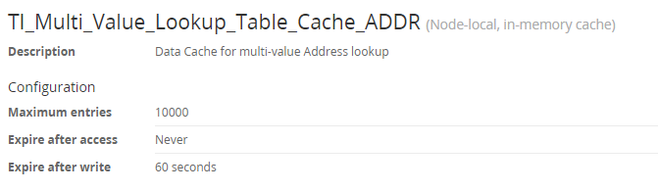

**Lookup Table:**

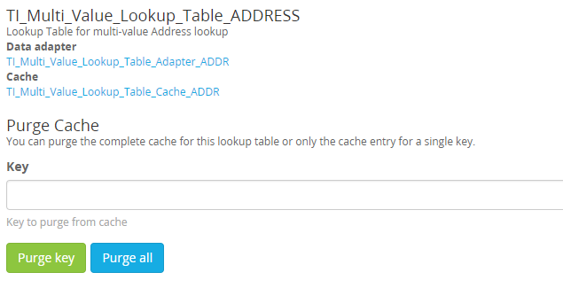

**Multi-Value Hash Lookup**

**Data Adapters:**

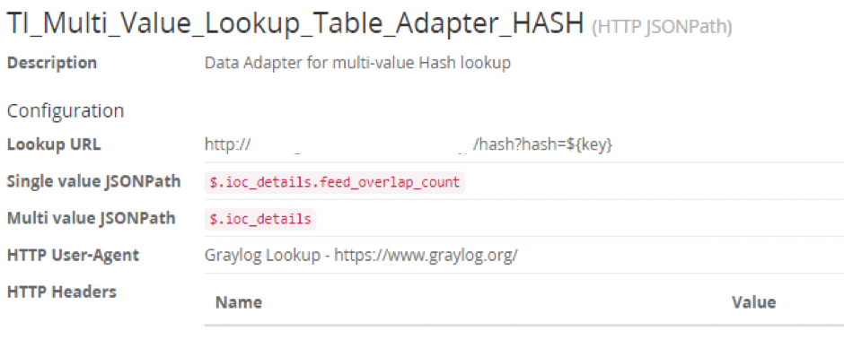

**Cache:**

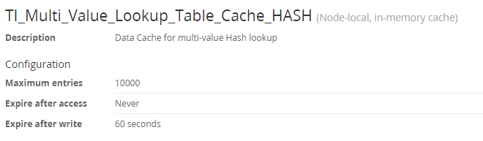

**Lookup Table:**

